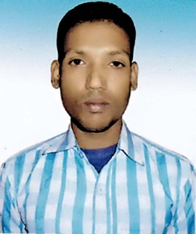**RESUME**

**Of**

**JAMINUR RAHMAN**

Mobile No: 01721-421228

Email: [jaminur](mailto:jaminur)17337@gmail.com

**Career Objective**

To work in to a leading organization that offers a competitive and performance based environment where I can get a platform to nourish my talents and utilize that for the development of the organization and build a smart as well as strange career for me.

**Educational Qualification**

**Bachelor of Arts (B.A)Honours**

Institution : Naogaon Govt. College, Naogaon.

Group : Bachelor of Arts

Subject : Islamic History of Culture

G.P.A : 3.04 Out of 4.00

Year : 2015

University : National University.

**Higher Secondary (Alim)**

Institution : Paranpur Kamil Madrasha, Naogaon.

Group : Humanities.

Year : 2010

G.P.A : 3.92 Out of 5.00

Board : Madrasha.

**Secondary School (Dakhil)**

Institution : Paranpur Kamil Madrasha, Naogaon.

Group : Humanities.

Year : 2008

G.P.A : 4.38 Out of 5.00

Board : Madrasha.

**Responsibility:**

* As I am connected with this job so I will gather experience and have working abilities in such respective fields.
* So, I can take all the responsibilities and decision, what will necessary to take at any situation whatsoever.

**Language proficiency**

|  |  |  |  |
| --- | --- | --- | --- |
| **Language** | **Reading** | **Writing** | **Speaking** |
| Bengali | Excellent | Excellent | Excellent |
| English | Good | Excellent | Good |

**Personal Information**

1. Full Name : **Jaminur Rahman**

2. Father’s Name : Nazim Uddin

3. Mother’s Name : Raziya

4. Permanent Adders : Paranpur, Fatgram-6511, Manda, Naogaon.

5. Present Address : Dupchanchia C-O Office, Dupchanchia, Bogura.

6. Date of Birth : 20-12-1993

7. Nationality : Bangladeshi (By Birth)

8. Religion : Islam

9. Marital Status : Married

10. Blood Group : A+

11. Sex : Male

12. Height : 5 Fit 9 Inch.

13. Weight : 62 Kg.

14. NID No. : 19936414781000294

**Experience:**

i) Position : Boro Bangladesh

Organization : Program Organizatir

Duration : From July 10 to tell now.

ii) Duties/Responsibilities :

Saving & Loan Collection

Group Meeting

Member Admission

Keep the Official Papers

Report Writing

**Personal Attributes**

* Self-confident and being positive.
* Ability to manage time and being flexible.
* Willing to accept responsibility and perform accordingly.
* Can work independently or within a minimum supervision.
* Open minded in adapting to new and challenging situations.
* Ability to work in teams and maintain effective communication skills.
* Full faith upon the Omnipotent Almighty Allah.

**Computer Skills:**

* MS Word, MS Excel, Email, Internet Browsing, Photo Shop, Power Point.

**References**

|  |  |
| --- | --- |
| **Sofiqul Islam**  Boro Bangladesh  Program Organizatir  Dupchancha Brinch 02  Cell No: 01722-538380 | **Monjurul Islam**  Boro Bangladesh  Senior Program Organizatir  Dupchancha Brinch 02  Cell No: 01766-141596 |

**Declaration**

I, the undersigned, declare that to the best of my knowledge and belief, the information given in these curriculum vitae is true, complete and accurate: my qualification, my efficiency in computer and language, references and me.

**Signature**

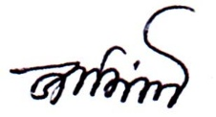

........................................................

Jaminur Rahman

Date: 09/10/2020.